# Lab 2. Simulation components of dynamic systems

**Name: Zhu Chenhao**

**ITMO ID: 375462**

## Specialization: Automation

|  |  |  |  |  |  |  |  |
| --- | --- | --- | --- | --- | --- | --- | --- |
| **Variant** | **U** | **psi** | **R** | **L** | **J1** | **J2** | **T_load** |
| 94 | 24 | 0.229183 | 0.35 | 0.00035 | 0.000225 | 0.001501 | 1.100079 |

**1. Simscape model of DC-motor.**

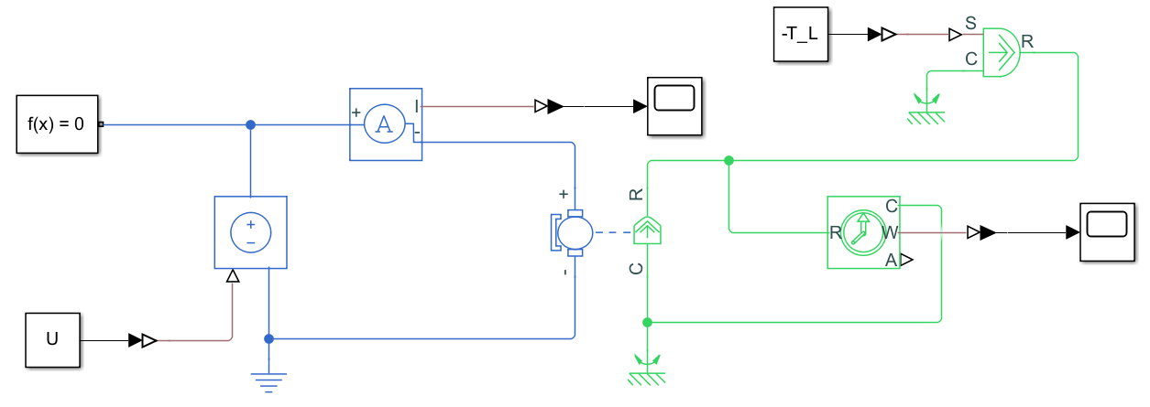

**Figure 1.** Equivalent circuit.

**2. Block diagram model of DC-motor.**

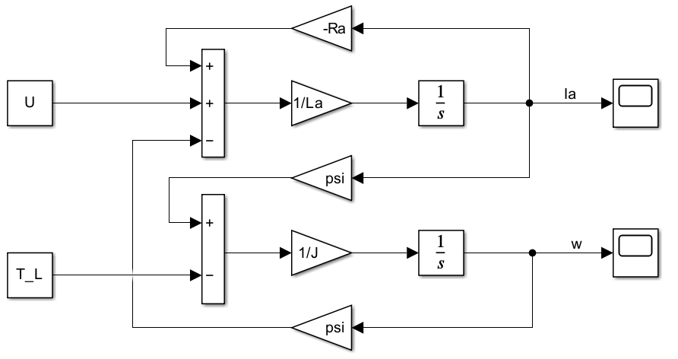

**Figure 2.** Simulation circuit.

**2. Transfer functions of DC-motor.**



**3. Topological equations.**



**4. State-space model.**

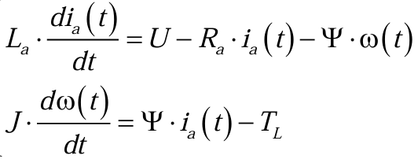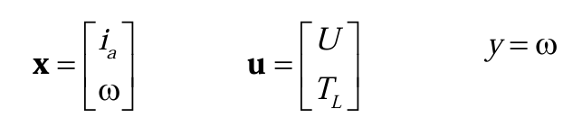



**5. Simulation results for 2 cases**

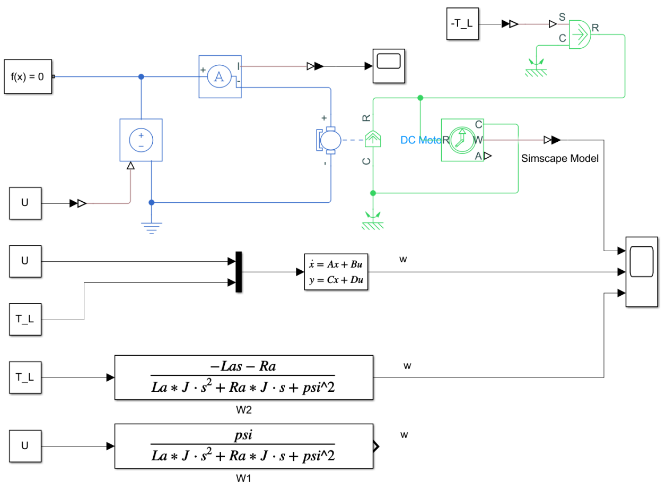

**Figure 2.** Three models

**Case 1:** U = U_rated; T_L = 0;

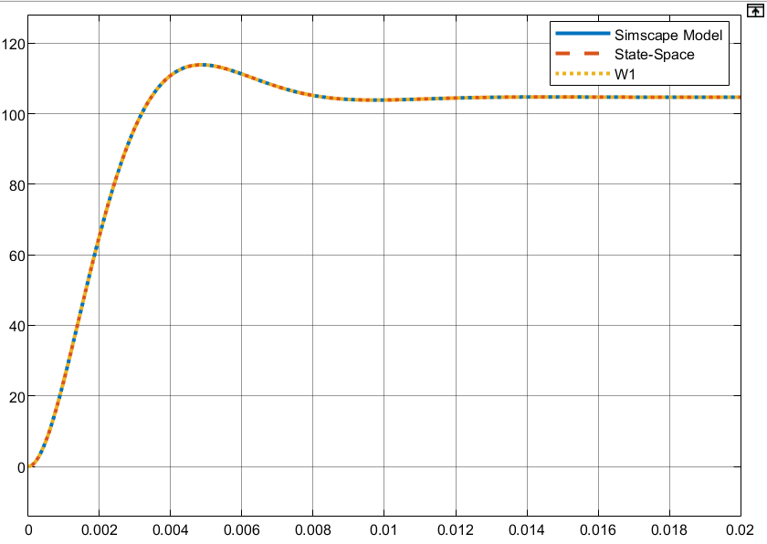

**Figure 3.** *Speed ω* **:** simulation results of case1 from three models.

**Case 2:** U = 0; T_L = T_rated;

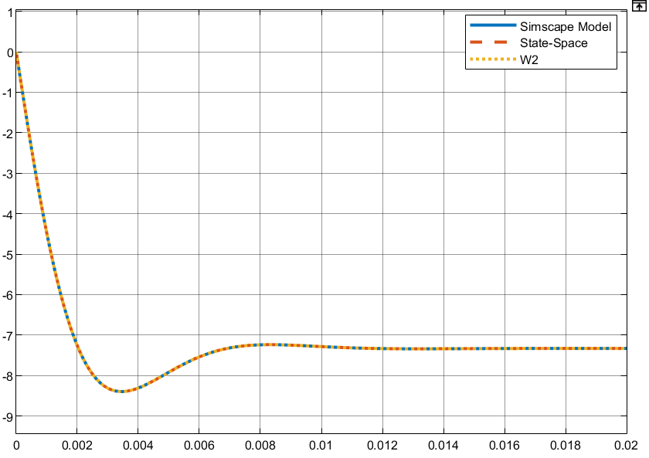

**Figure 4.** *Speed ω* **:** simulation results of case1 from three models.

**6. Calculation of transient response.**

**Case a)** *U = Urated = 24, J = J1 = 0.225e-3:*

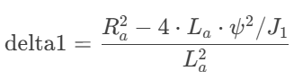

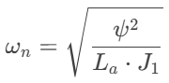 , 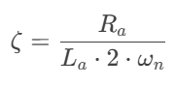 , 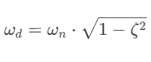

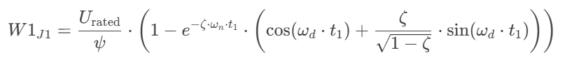

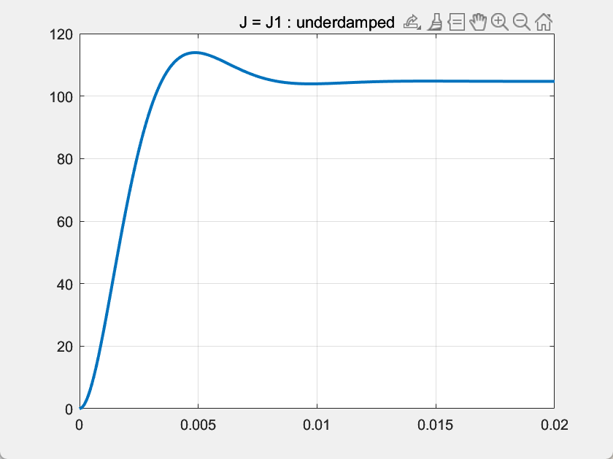

**Figure 5.** *Speed ω* **:** simulation result of underdamped sys in MATLAB.

Because *ζ < 1 ,* so this case is an **underdamped** system

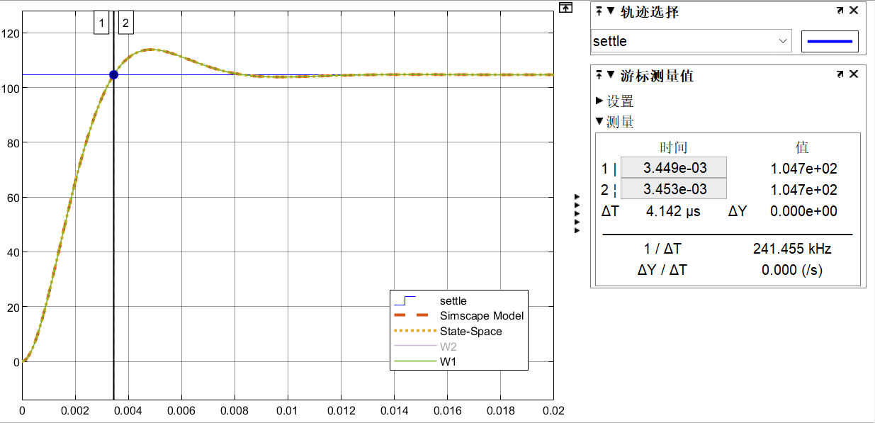 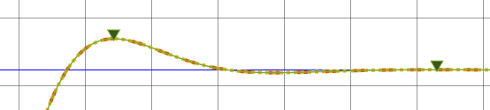

**Rise time** from 0% to 100%: **3.45e-03 s**

**Maximum** (percent) overshoot: (1.139-1.047)/ 1.047*100% = **8.7870%**

**Settling time** with 5% tolerance: **6.373e-03 s**

**Case b)** *U = Urated = 24, J = J2 = 1.501e-3:*

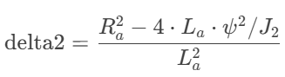

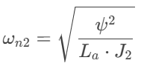 , 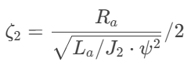

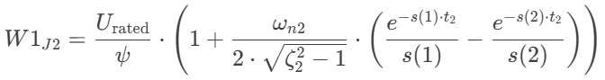

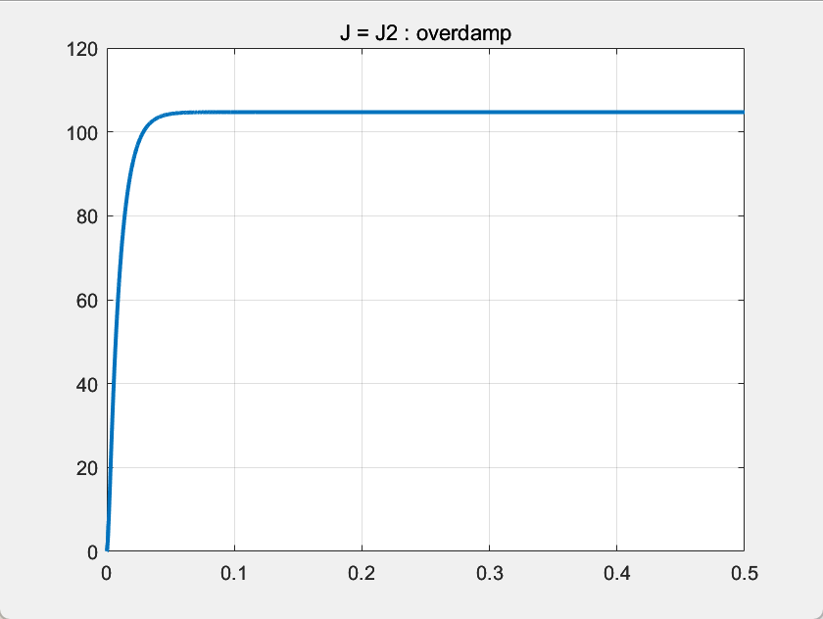

**Figure 6.** *Speed ω* **:** simulation result of overdamped sys in MATLAB.

Because *ζ > 1 ,* so this case is an **overdamped** system

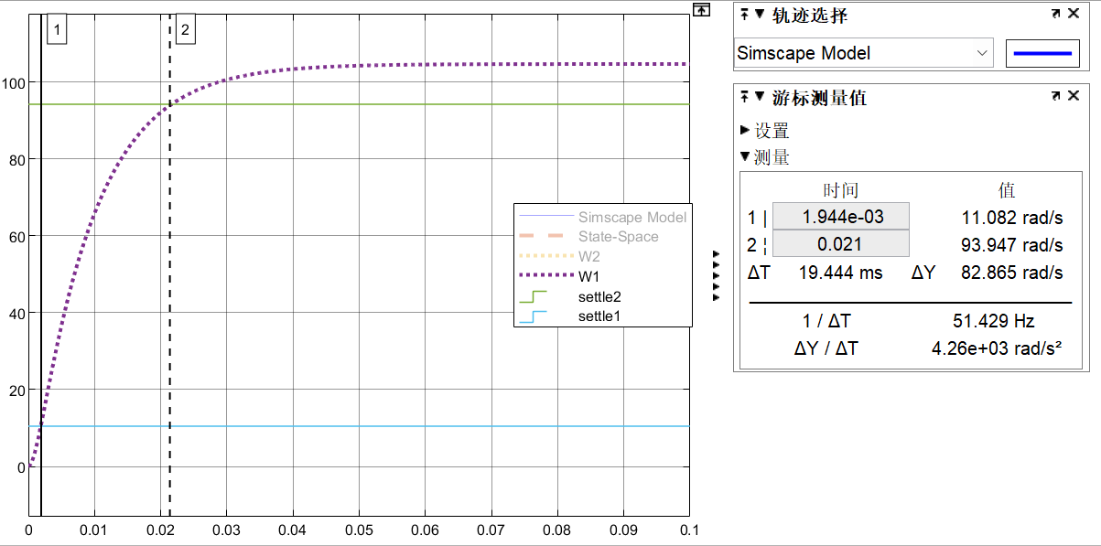

**Rise time** from 10% to 100%: 0.021- 1.944e-03 = **0.0191 s**

**Maximum** (percent) overshoot: **NONE**

**Settling time** with 5% tolerance: **0.028 s**

**7. Bode plot of underdamped model**

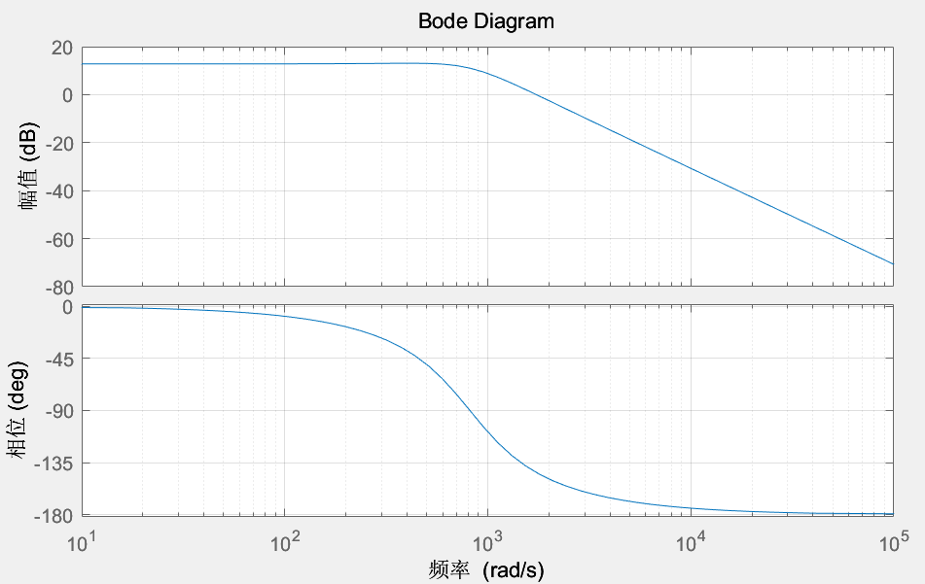

**Figure 6.** Bode of W1

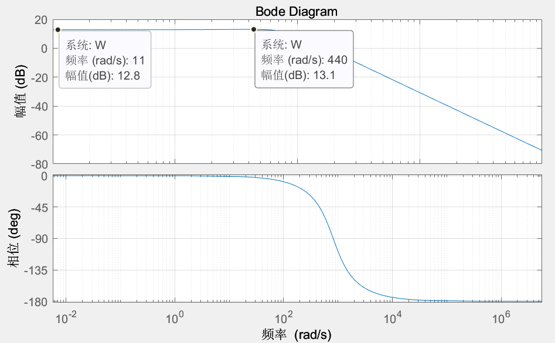

*Values of the static gain :* 

*damped natural frequency :* 

**Conclusions:**

1. **Dynamic Models**:

The DC motor was successfully modeled in different forms, including the Simscape block, block diagram, transfer function, and state-space representation. Each model provided a unique perspective on the system's behavior, allowing for a comprehensive understanding of the motor's dynamics.

1. **Transient Processes**:

The transient response of the DC motor was analyzed under two cases: with rated voltage and no load torque, and with no voltage and rated load torque. The results showed distinct behaviors for underdamped and overdamped systems:

**Underdamped System (J = J1)**: The system exhibited oscillations with a rise time of 3.45e-03 s, a maximum overshoot of 8.7870%, and a settling time of 6.373e-03 s.

**Overdamped System (J = J2)**: The system response was slower and did not exhibit oscillations, confirming the overdamped nature.

1. **Bode Plots**:

The Bode plot for the underdamped model was constructed, providing insights into the frequency response of the system. The plot revealed the system's gain and phase margins, which are crucial for understanding the stability and performance of the DC motor.

1. **Simulation Results**:

The simulations demonstrated the effectiveness of the models in predicting the motor's behavior under different conditions. The results from the Simscape model, block diagram, and state-space model were consistent, validating the accuracy of the mathematical representations.